**Spiral Maze Lab Instructions**

**Lab Goal:** This lab was designed to help you review loops and to learn more about how you can combine loops and ifs to solve problems. You must determine how and when to turn, and most importantly when to stop. You must create if commands based on the requirements of this problem. Pay close attention – it will only require a few basic decisions if you take a careful look at the decisions that need to be made.

**Lab Description:** This lab requires that you use recursion with if statements. Your Jeroo must make its way through the entire maze and stop before jumping into the water. You should be able to make the Jeroo spiral in to the center and then spiral back out to the start. **Your code must be able to run with all three island files and you must use recursion.**

**Files Needed:**

**sprialmazeRecursion.jsc**

**SpiralMazeIsland1.jev**

**SpiralMazeIsland2.jev**

**SpiralMazeIsland3.jev**

**Starting Screen:**

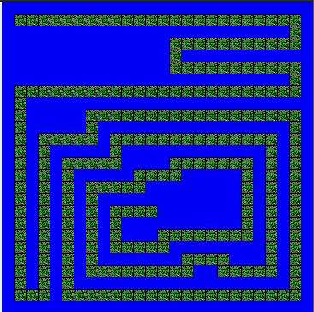

***algorithm help***

**Preconditions**

* **I am facing the path?**
* **Is it clear to move ahead?**
* **Do I turn left or right?**
* **Should I stop?**

**Postcondition**

* **Successful hop through the maze**
* **Jeroo is not in the water**
* **Jeroo is facing West**
* **Jeroo stops facing the water.**

**Middle Screen:**

